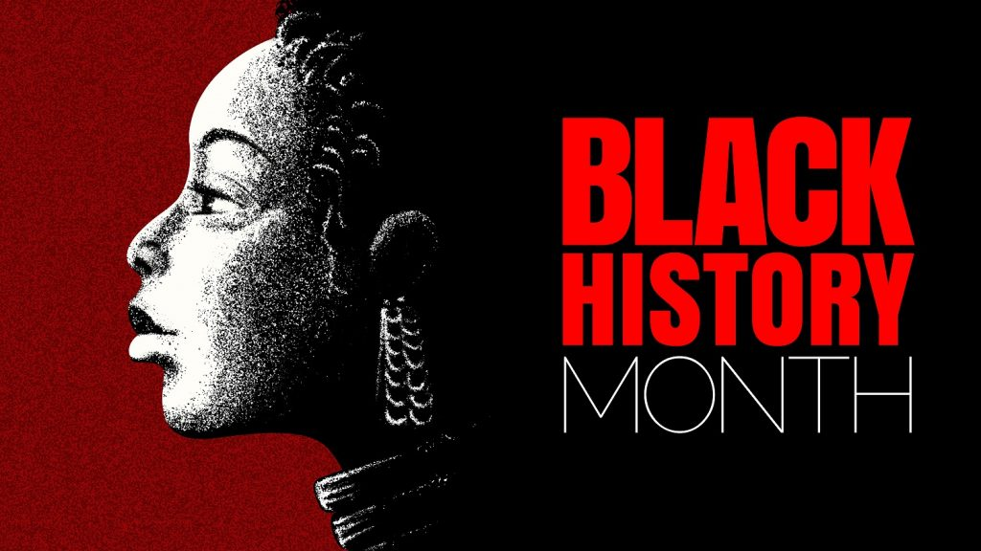
Unit III - #BlackHistoryMatters

Final project : For the Black History Month you’re going to create an exposition to pay tribute to a prominent figure of the Civil Rights Movement in America. You have to choose one person and create a poster on which the spectators will see: a picture, a quotation, some details and a QR code for a virtual presentation. You will also create a quiz so that the visitors can test their knowledge at the end of the visit.

Mini-Project: Create the poster to present your exposition.

