
Rosa Parks
Pesonnal Informations :
Born : February 4, 1913 in Tuskegee
Death : October 24, 2005
Her family live by her grand parents. Her great-grand parents was slaves. When she was young, it was segregation between black and white people. At that time there was the Ku Klux Klan. It was a band of hate-filled whites. Rosa’s school was open just five months a year. It was a school for Africans Americans.
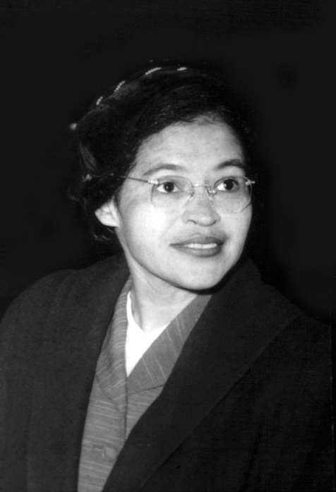
In December 1932, at the age of 19, did she marry her husband. It was Raymond Parks a barber and a man active in the struggle for the rights of African Americans.
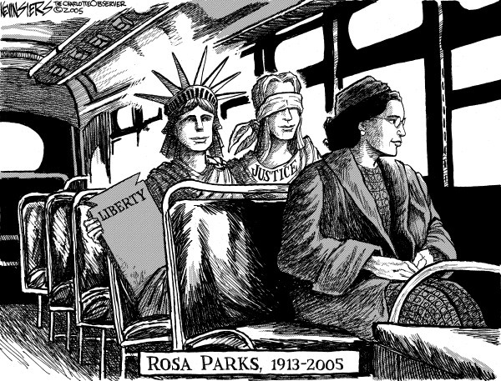

Important event :
In the 1940s Rosa Parks join the NAACP. It was an organisation that worked to end the unfair traitement of Africans Americans and ethern. One day in 1943, Rosa refused to give up her seat to a white man on a bus in the city of Montgomery. But it was forbidden for a black person. On Tuesday December 1st, 1955, Rosa Parcks was arrested in Montgomery. Against that, Black Americans refused to ride on public buses in Montgomery. So on November 13th, 1956, the United States Supreme Court ruled that segregation on public buses was against the law. This was the most famous act of Rosa Parcks.

