Norman Rockwell

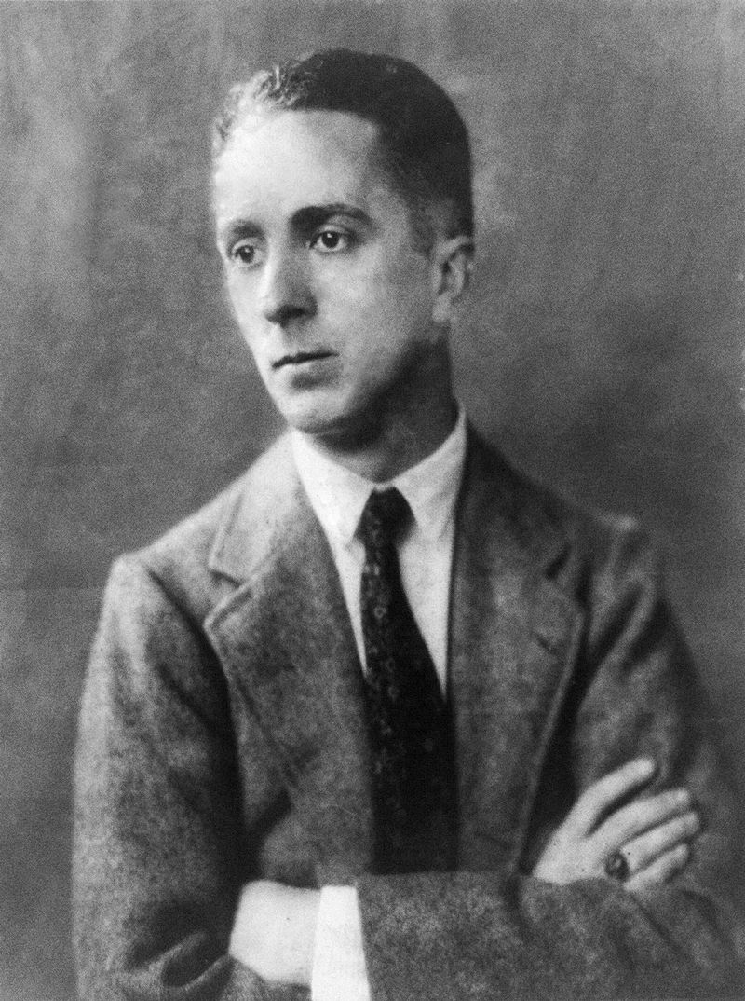

- Birth : February 3, 1894 new York

- Death : November 8, 1978 (aged 84) Stockbridge

- Birth name : Norman Percevel Rockwell

- Activity : Nationality United States Flag United States Painter, illustrator

- Training : Art Students League of New York

- Master : George bridgman

- Work places : Los Angeles, Arlington, New York, New Rochelle, Stockbridge

- Movement : American Realism

