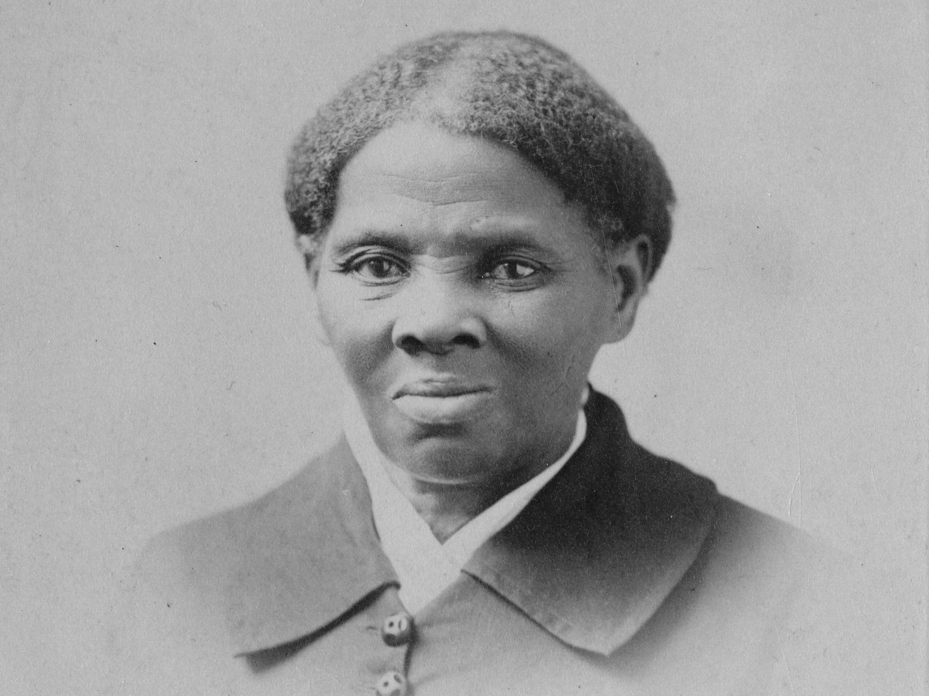
Harriet Tubman

Harriet Tubman was born slave in the year 1820.
She was leased by many sellers. One day she took a head shot by a somebody shooting a thief.
So she become narcoleptic all her life.
His father place her in contact with marines. She learn many important informations.
Later she escape with two of her brothers because she dreamed and she discovered a way to escape in this.
During her life, she helped slaves to quit south America to go to north America by using a small path in the forest.
Later she fought against segregation and for the women vote in protest march.
She escaped more than 300 people during her life as a slave.
