HOW TO DEAL WITH PICTURES

A CARTOON

ON THE LEFT AT THE TOP ON THE RIGHT
In the top-left hand corner
In the top right-hand corner
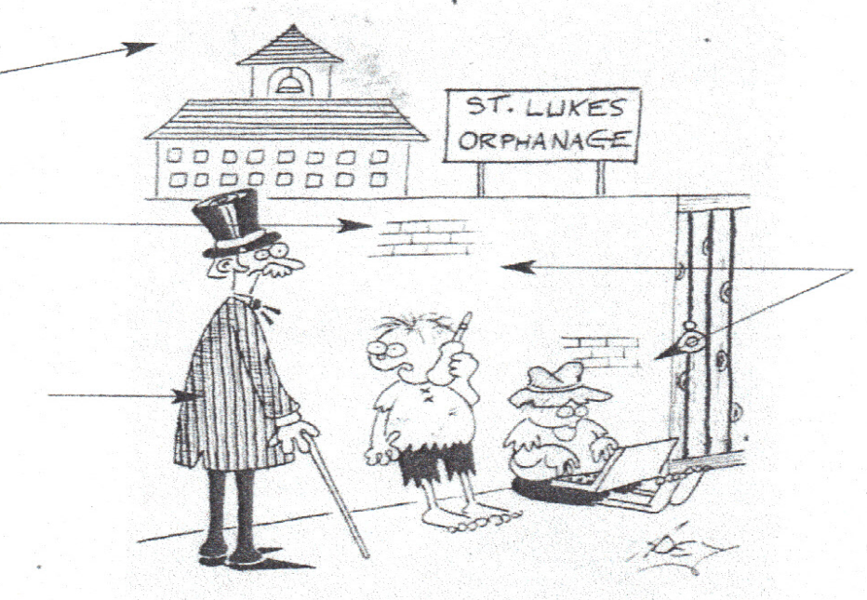
In the background
The focus ( the centre of interest )
In the foreground
In the middle
The caption
I got an Orange for Xmas and my brother got an Apple .
In the bottom left-hand corner
AT THE BOTTOM
AT THE BOTTOM
In the bottom right-hand corner

A COMIC STRIP/ A STRIP CARTOON

A speech = a balloon
The punch-line
A frame
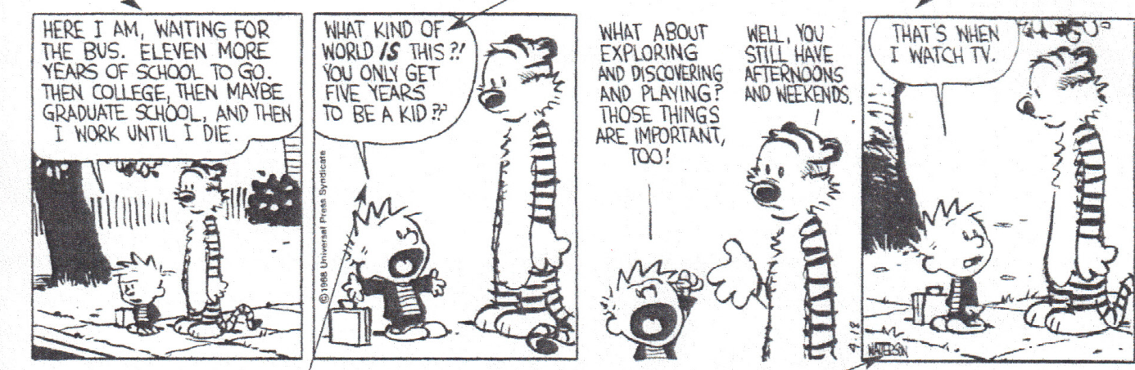
The cartoonist’s signature
The balloon pointer

AN AD / AN ADVERTISEMENT
THE CATCHPHRASE

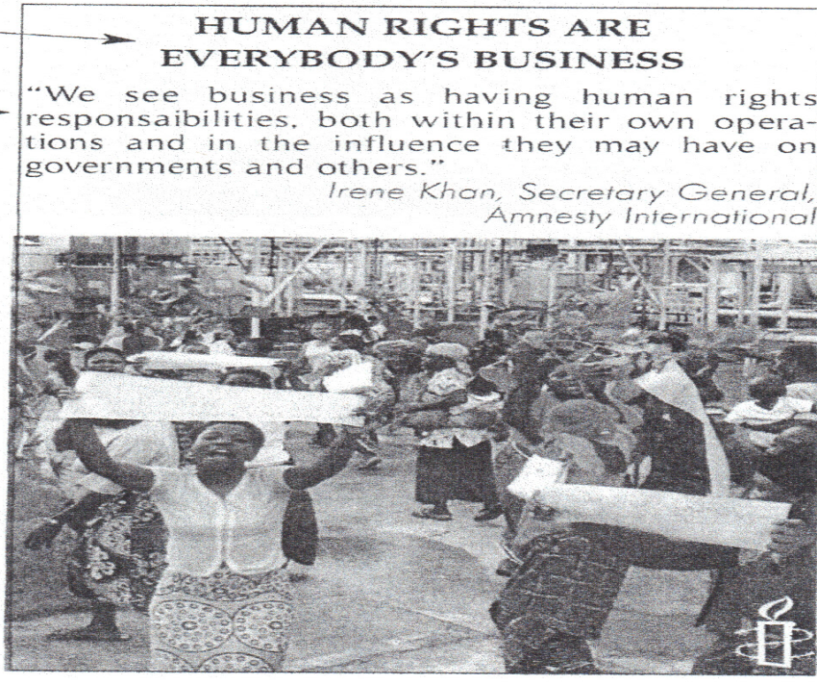
THE BRANDNAME = THE TRADEMARK = a registered name used to identify a company’s good.
THE ADMAN = the artist who made the ad.
THE TARGET= the people or cosumers the ad is aimed at.
THE ADVERTISER = the person or company who paid for the ad..
THE SLOGAN= a striking phrase to help people remember who is advertised.
A LOGO
THE COPY

CINEMA SHOTS
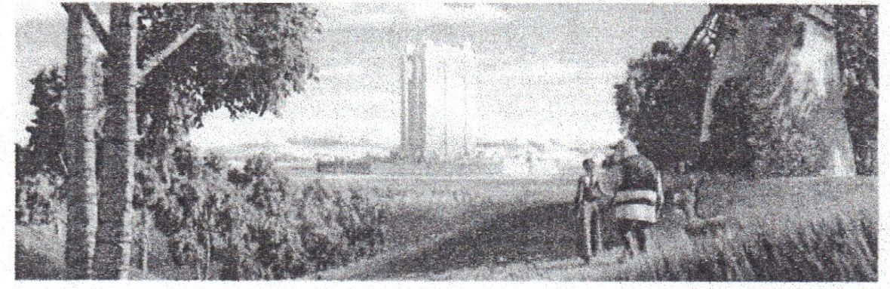
WIDE-ANGLE SHOT OR PANORAMIC VIEW : the horizon is far away, the environment is more important than the characters
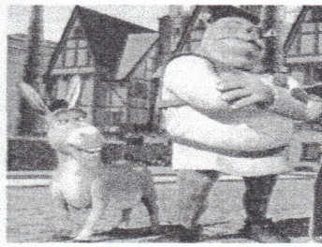
DOWNWARD SHOT
It gives a survey of the situation and often a humourous or ironical distance .
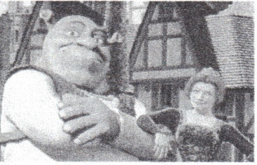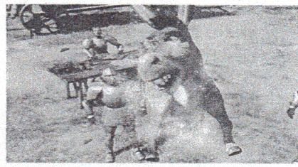
FULL LENGTH SHOTS :the characters matter more than the environment.
MEDIUM SHOT : the way we normally see the people when we talk to them.It gives the spactator the impression to be present to the scene.
UPWARD SHOT. It makes the spectator feel small and respect or fear the character he is looking at .
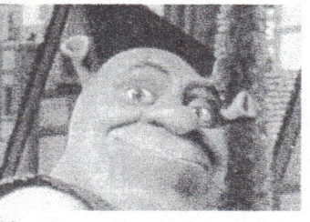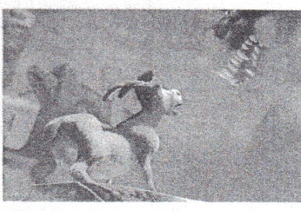
CLOSE-UP : more intimacy with the character.

