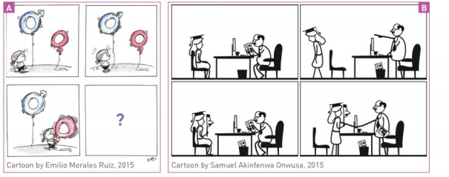
USEFUL VOCABULARY
A balloon / To stand for = to represent / A male / female gender symbol / To be surprised = to be stunned = astonished /To blow into a balloon / to inflate a balloon / To rise in the air / To apply for a job / to expect to be recruited ; to be hired / a resume / a graduation hat / to be skilled /To be turned down / An applicant / To be treated unfairly /to be prejudiced / to be narrow -minded

- Describe the pictures
- Tell the story with link words
- Imagine what is going to happen .
- Are the drawings powerful ? convincing ?
- What is the message which is conveyed ?

