The superlative

It’s the oldest buiding !
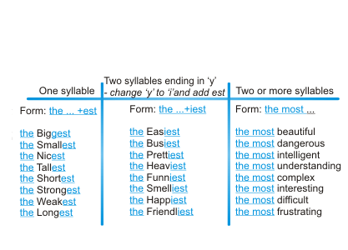
Irregularities
Good = the best / Bad = the worst / Far = the furthest

