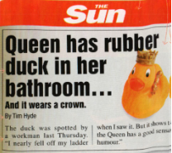

AN EDITOR
A REPORTER
THE NEWS

AN ARTICLE
A NEWSPAPER
A HEADLINE

A FRONT PAGE

A PHOTOGRAPHER
A PHOTOGRAPH

