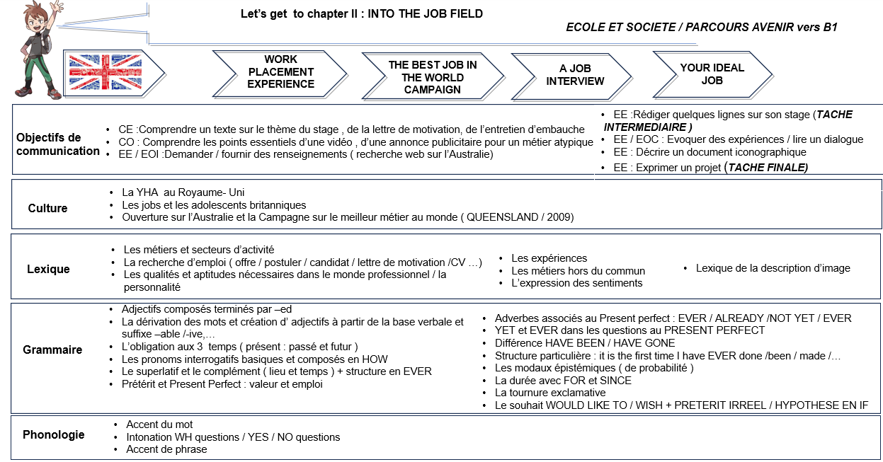
I. WORK PLACEMENT EXPERIENCE
- YHA and its job offer ( jobs )
- Linda’s application letter (composition des adjectifs).
- Linda’s report (have to).
- Your report EE (TI )

II. THE BEST JOB IN THE WORLD CAMPAIGN
- Australia: main facts (WH – question words / introduction of the superlative )
- The Best Job in the world Campaign and unusual jobs (Superlative + EVER = Preterite /Exclamation )
- Ben Southall’s application PRESENT PERFECT+ ever/never /already / not yet / BEEN = GONE
- And the winner is…( méthodologie : image +modaux)

III. A job interview
- It is her first full time job : reprise it is the first time +PP
- An experienced young woman :
DURATION ( FOR /SINCE +PP)
IV. Your ideal job
- Different jobs
- What is your ideal job :would like to / to wish +fictive preterite / hypothesis and conditional

