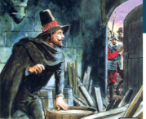

NOVEMBER, 5TH 1605

