Higher and higher in NEW YORK !

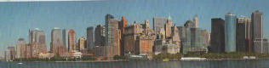

The SKYLINE
What a terrific view ! This is New York City and everything is modern and gigantic .Look at these buildings .The line formed by those towers is called the Skyline.
You think the buildings are so high they can almost touch the sky !Well, that’s why we call them skyscrapers .
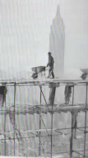

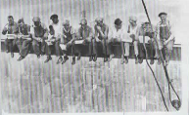
At lunchtime,1932

IN THE BEGINNING
Skyscrapers are quite old.They were born in the 1880’s thanks to several innovations ; steel structures and elevators .Manhattan was the ideal place because it is a single chunk of granite, perfect for the foundations tall buiding need.

Mohawk Indians who were fearless at walking and working hundreds of feet in the air were good ironworkers.

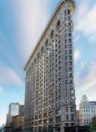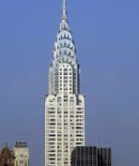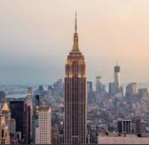
FLATIRON BUILDING CHRYSLER BUILDING EMPIRE STATE BUIDING
( 1902 / 285 feet ) ( 1930/ 1,050 feet ) 1931 ( 1.224 feet )
It is one of the oldest New It is a dazzling Art-Deco style It looks like a pencil .It is
York City Skyscrapers. Tower.WALTER.P CHRYSLER the highest building in
Guess why they call it was a millionnaire and a car New York .
The Flatiron Building ? company owner. So, the top of
Look at its triangular shape. the tower looks like a car’s
It looks like an iron. hubcaps.

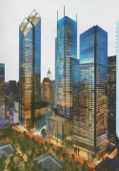

The changing face of NEW YORK

The two identical 110-story towers of

the World trade Center were symbols of New York City. The site is now being rebuilt after the terrorist attack of September 11th, 2001.
Look at the image of the project designed by group of architects. It includes six new skyscrapers, a memorial to the casualties of the attack, a hanging garden , a cultural center and the Freedom center ( 1,776 feet tall ) .

