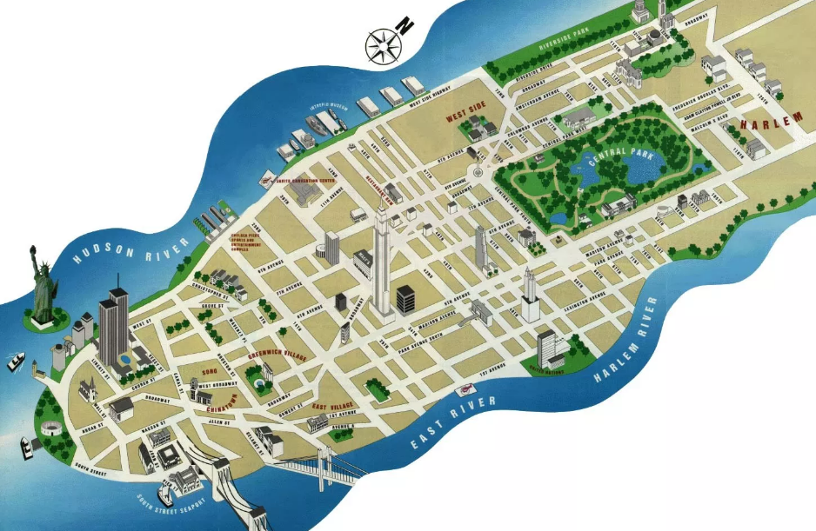

MANHATTAN
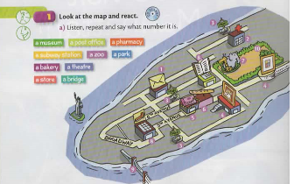

LISTEN TO THE AUDIO,REPEAT AND SAY WHAT NUMBER IT IS :

a museum a bridge a theatre

a pharmacy a zoo

a post office a park

a subway station a store

A zoo

A park

A bakery

A theatre

A store

