THE COMPUTER

THE PUC
THE SCREEN

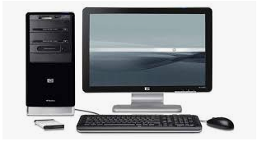
A LAPTOP
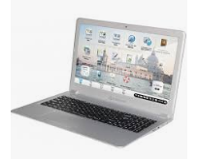
THE KEYBOARD
THE MOUSE

