THERE IS / THERE ARE

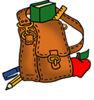 |  |  | 1. There is a book in the bag.
 |  |  | 2. There is a ruler in the bag.
 |  |  | 3. There is an _______________________ next to the bag.
 |  |  | 4. There is a ______________________________ behind the bag.
 |  |  | 5. There is a pen __________________________ the bag

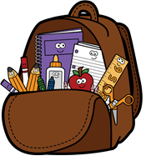 |  |  | 1. There are books in the bag.
 |  |  | 2. There ________________________ scissors in the bag.
 |  |  | 3. _____________________________ an apple in the bag.
 |  |  | 4. ___________________________ a glue stick in the bag.
 |  |  | 5. _______________________________ pencils in the bag.
 |  |  | 6. _____________________ a ruler in the bag.
 |  |  | 7. ______________________________ crayons in the bag.

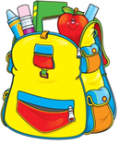

1. There is a crayon in the bag.
2. _________________________________ an apple in the bag.
3. _________________________________ pencil in the bag.
4.________________________________________________.
5. ________________________________________________.

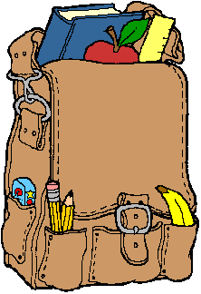 |  |  | 1. ________________________________________________.
 |  |  | 2. ________________________________________________.
 |  |  | 3. ________________________________________________.
 |  |  | 4. ________________________________________________.
 |  |  | 5. ________________________________________________.

