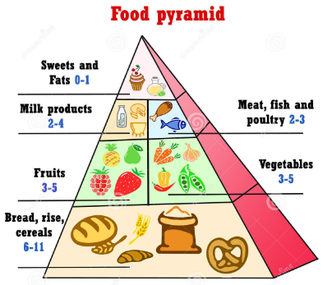

WHAT YOU MUST EAT !!!

