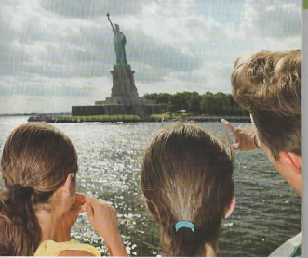

LET’S VISIT MANHATTAN

