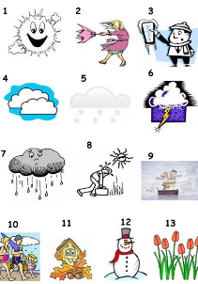

1
FREEZING
AUTUMN
SPRING
SNOWY
RAINY
HOT
CLOUDY
SUMMER
FOGGY
WINTER
STORMY
SUNNY
WINDY

THE WEATHER
Match ( associate ) the pictures ( images) and the words : it is …

