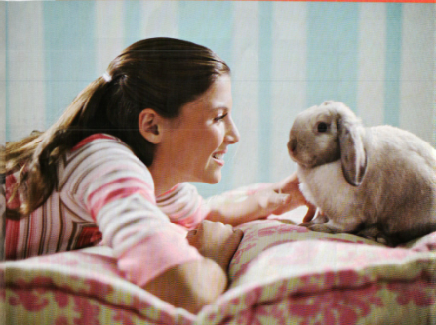

USEFULVOCABULARY
To lie on the bed
To look happy / not to look afraid / to look close to the pet / To look confident / to trust
A great responsibility
Peaceful / calm

