

NEAR OPPOSITE

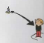
BEHIND FAR FROM

