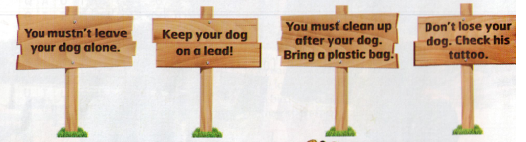

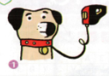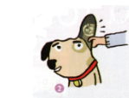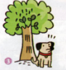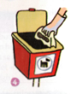

BE A GOOD DOG OWNER : MATCH THE PICTURES WITH THE SIGNS

