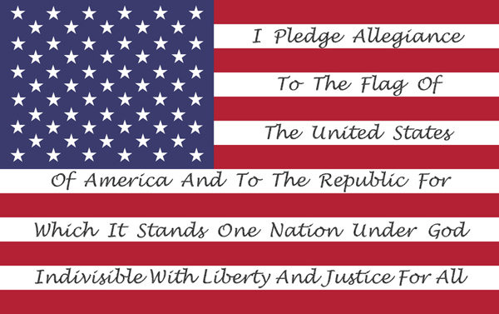
- It started in 1887 but was finally adopted in 1942 ( fourteen ninety two )
- It is a way to celabrate the 400th (four hundredth ) anniversary of Christopher Columbus arrival in America.
- When school starts in the morning, all the pupils sing it together . Some words changed :
« My flag » became « the flag of the United States » / « Under God » was added in 1954
. The American flag is also called the Stars and Stripes or the Star-Spangled Banner ( which is the name of the National anthem ). It was created in 1777 as a way to indicate the independence of the 13 first colonies in A merica .

- The American flag is also called the Stars and Stripes or the Star-Spangled Banner ( which is the name of the National anthem ).
- It was created in 1777 as a way to indicate the independence of the 13 first colonies in A merica .

THE PLEDGE OF ALLEGIANCE

