WHAT DO THEY LIKE ?

HE / SHE LIKES 

HE/SHE DOESN’T LIKE 
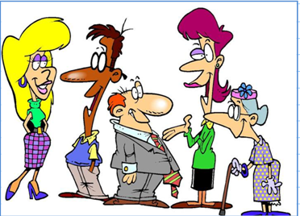

- Have a look at the chart
HOBBIES | EVA | TOM | JOE | TINA | MISS TATE
READING |  | 
PLAYING GOLF

READING COMICS
GARDENING

PHONING FRIENDS
WATCHING

- And now make up sentences : Eva likes …….and she likes ……..but she doesn’t like ………………………

