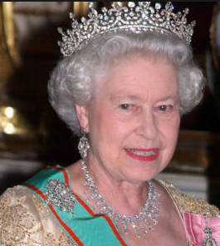
1.Label the picture with physical traits

2 .Write the number corresponding to the body part
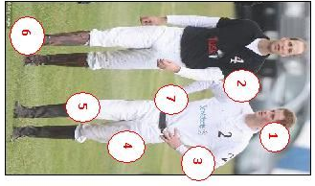
Head …………
Hands ……
Shoulder ……
Foot ( 2 feet )………
Leg ……………….
Arm ………………
Knee ……………….

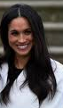

Indicate their type of hair
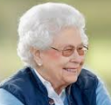
$

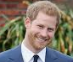

………………………………………………………………………………………………………………………………………………………….
…………………………………………………………………………………………………………………………………………………………

………………………………………………………… …………………………………………………….
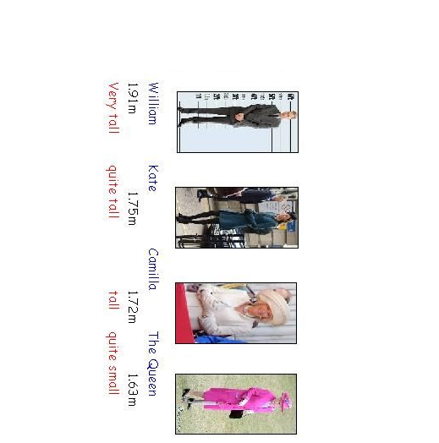
How tall are they ?

………………………………………………………………………………………………………………………………………………………………………………………………………………………………………………………………………………………………………………………………………………………………………………………………………………………………………………………………………………………………………………………………………………………………..

