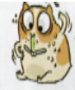
MAGNET HARRY VANILLA

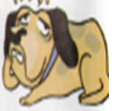
CHIP CHUBBY

Useful Vocabulary
UGLY
ENERGETIC
CUTE
GREEDY ( likes eating )
LAZY

