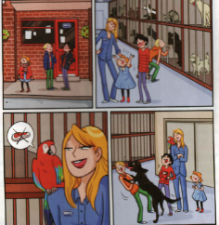
RSPCA


RSPCA
Royal Society for the Prevention of Cruelty to Animals
Useful vocabulary
A SHELTER
ABANDONED ANIMALS
TO BE AFRAID /AGGRESSIVE
A PARROT
SHOULDER
TO JUMP ON ….
TO LAUGH

