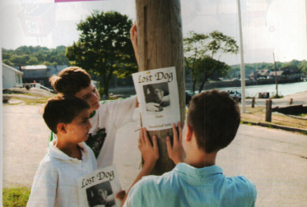
REWARD
TUCKER
USEFUL VOCABULARY
To stick a poster / a missing dog / reward / to invite people to call / A great responsibility /to protect / to abandon

