1 .Fill in the spaces with the correct form of the verb in simple present tense.
1) Mary (go) _______________________ to school at 8 a.m
2) We (like) __________________ to eat fruit. It (taste) __________________ good.
3) The football team never (score) ________________ . It (lose) ____________ all the time.
4) Roberta and Betty (not / speak) _____________________ English.
5) Joey and I (study) _____________________ Maths together
6) Angelica ( not / try) ____________________ to make new friends.
7) James (run) _______________________ two miles every day.
8) Elizabeth (not /buy pet food) _____________________ twice a week : she only ( buy ) _________________some once a week .
9) John and I (open) __________________ presents at Christmas.
10)What time ( you / get up ) __________________ in the morning ?
11) How often ( you / go )_________________________to the cinema ?
12 ) My sister ( to feed )___________________her cat three times a day
13) How often (they / take ) _____________________the dog to the vet’s ?

2.This is Lynn’s agenda : describe her daily activities
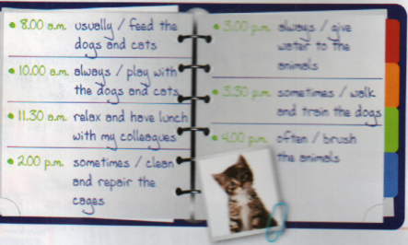

3.Ask the questions corresponding to the answers
a) …………………………………………………………………………………
My kitten eats sausages and fish.
b) …………………………………………………………………
No , they don’t .Canaries don’t drink a lot of water.
c) …………………………………………………………………..
My dog goes to the park every day.
d)………………………………………………………………..
It’s Linda .Linda takes care of the animals in the shelter.
e)……………………………………………………………..
Yes, they do.Guinea pigs eat fruit.

