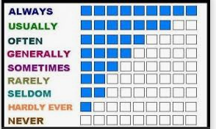
100 % .......................................................................................
90 % ………………………………………………………
60 % ……………………………………………………….
50% ………………………………………………………………
30% ……………………………………………..
5% ......................................................
5%........................................................
2%..........................................................
0%...........................................................

POSITIONNEMENT ADVERBES :
…………………………………………………………………………………………………………………………………………………………………………..
………………………………………………………………………………………………………………………………………………………………………..
………………………………………………………………………………………………………………………………………………………………………..

