

PRESENT SIMPLE

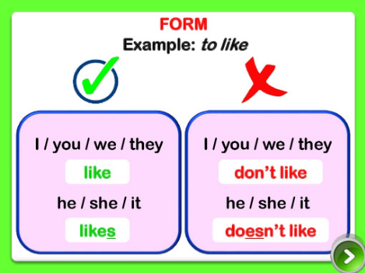
Questions
DO | I /YOU/WE / THEY | LIKE | READING ?
DOES | HE / SHE / IT | LIKE | READING ?
- Je remarque l’……………………………………de ………………….qui devient ……………………à la ………………………………………………………….C’est un …………………………………..qui permet au verbe …………………………..de se CONJUGUER au ………………………………………………………………………………

