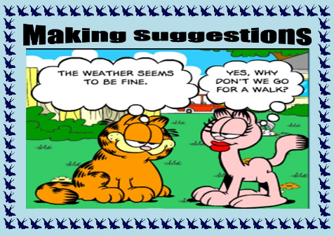

Let’s ( us ) + base verbale ( Let’s visit Manahattan ! )

How about + V.ING ( How about going to Central Park ? )

What about + V.ING( What about going to Fifth Avenue?)


It’s up to you to practice now !
- Make suggestions !
- …………………….watch Netflix !
- ………………….going skiing ?
- ………………..have a pizza !
- ………………………looking at this video ?
- My parents are away for the weekend : ………………have a party and a sleepover !
- Put it into English
- Et si on allait au park ? ………………………………….
- Faisons les magasins ! ( do some shopping )………………
………………………………..
- Et si on se promenait ( to go for a walk ) ? Il fait beau !
…………………………………………………………………………..
- Allons à la piscine ! …………………………….
- ) Et si on écoutait de la musique ? ……………..
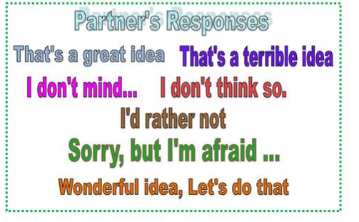


- And now invent a dialogue between two friends ( two boys or
girls.
Three activities are suggested but two are refused and you must indicate the cause.One is accepted.



