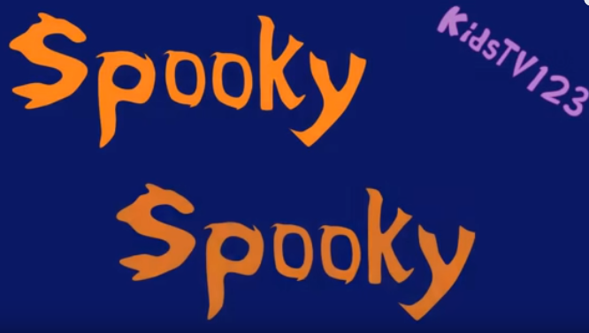
Written and performed by A.J. Jenkins.

Spooky spooky - very spooky. Oh no! It's a monster
Spooky spooky - very spooky What's that? It's a witch !
Spooky spooky - very spooky Watch out! It's a vampire !
Spooky spooky - very spooky What's that? It's a ghost !

Spooky things doing a spooky dance
Spooky things doing a spooky dance
Aaah aaah aaah Wooo wooo wooo
What kind of spooky thing are you?
Aaah aaah aaah Wooo wooo wooo
What kind of spooky thing are you?

Spooky spooky - very spooky Oh no! It's a black cat
Spooky spooky - very spooky What's that? It's a spider
Spooky spooky - very spooky It's a Jack O' Lantern
Spooky spooky - very spooky What's that? It's a skeleton
Spooky things doing a spooky dance
Spooky things doing a spooky dance
Aaah aaah aaah Wooo wooo wooo
What kind of spooky thing are you?
Aaah aaah aaah Wooo wooo wooo
What kind of spooky thing are you?
Spooky spooky- very spooky Spooky spooky- very spooky Spooky spooky- very spooky

