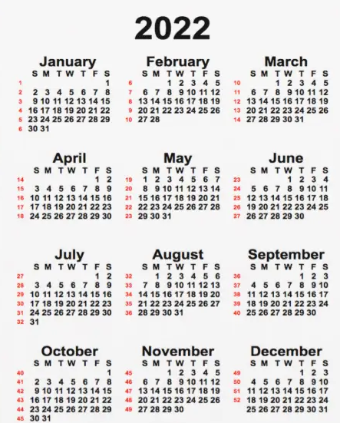
BIRTDAYS AROUND THE YEAR

