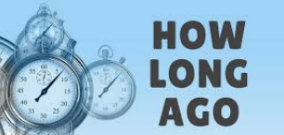
FAMOUS WOMEN IN HISTORY

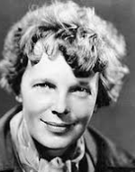
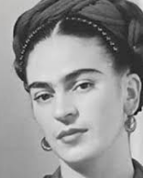

Write down the biography of one these famous women
name | Her name is ……..
Date of birth | She was born in ….., on ……
Date of death | She died on ….
family | She had …… / She was married to / with……..
nationality | She was from , so she was
job | She worked as
studies | She studied at …/She was a student
accomplishments | She was famous by +Ving …. /she succeeded in + V.ing

Now , have a look and react
- Amelia EARHART was born in 1897, …………………years AGO.
- Frida KHALO died in 1954,…………………………….years ago.
4 HOURS AGO


2 P.M 6 P.M
NOW
DATED ACTION

