

A road trip to the US
i WOULD LIKE TO VISIT…


This video presents the 10 MUST visit cities in the US : https://www.youtube.com/watch?v=46SYtrSe-X4
Watch it and complete the chart:
Cities | State | Interest
10-
9-
8-
7-
6-
5-
4-
3-
2-
1-New York City | New York

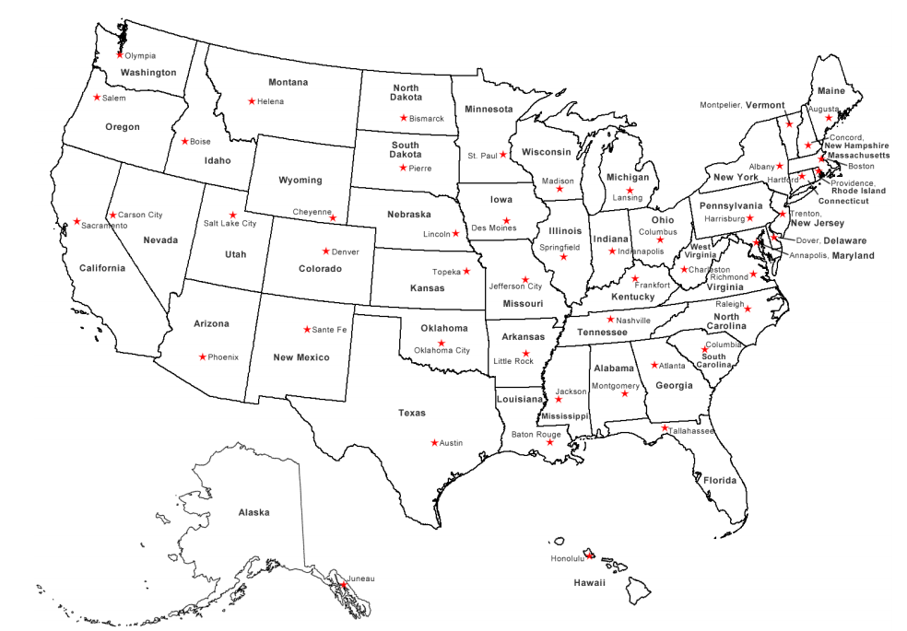
Highlight OR add them on the map:

After New York, where would you like to go? Why?

I would like to go to _ _ _ _ _ _ _ _ _ in _ _ _ _ _ _ because there is/are _ _ _ _ _ _ _ _ _ _ _ _ _ _ _ _ _ _ _ _ _ _ _ …

