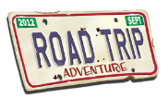
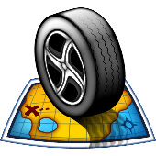
A road trip to the US
PLANNING MY TRIP

What will I do in the USA?
- Brainstorming
Accomodation

Activities

Food

Gifts

MY TRIP TO THE USA
Means of transport

- Write about your plans:

Means of transport: I
TOOLBOX :
Take : prendre
Sleep : dormir
Rent : louer
Eat : manger
Visit
Go shopping
Walk : marcher
Buy : acheter
I
Accomodation:

Food:

Activities:

Gifts:

