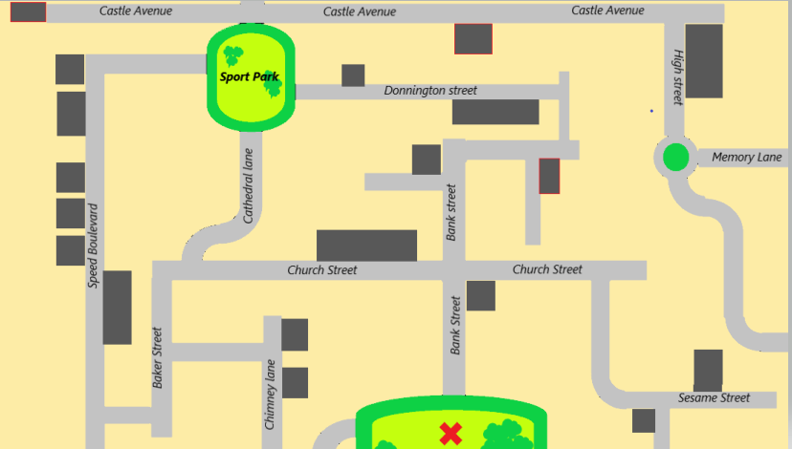
- Listen and retrace the itinerary on the map.

- Listen and retrace the itinerary on the map.

- Listen and retrace the itinerary on the map.

- Listen and retrace the itinerary on the map.

