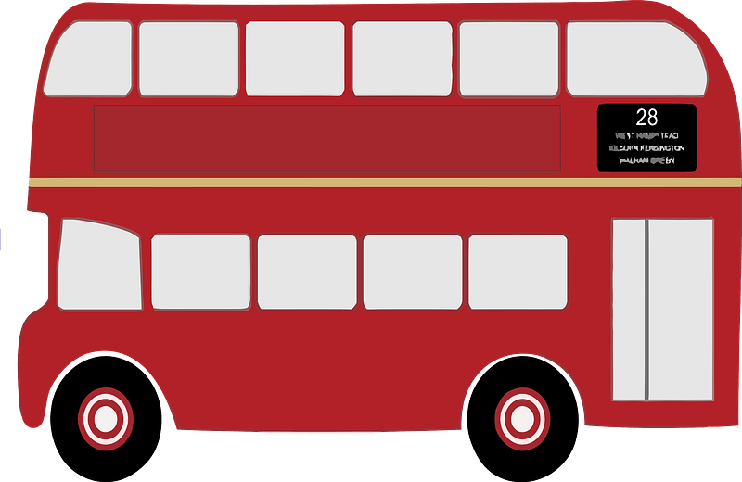
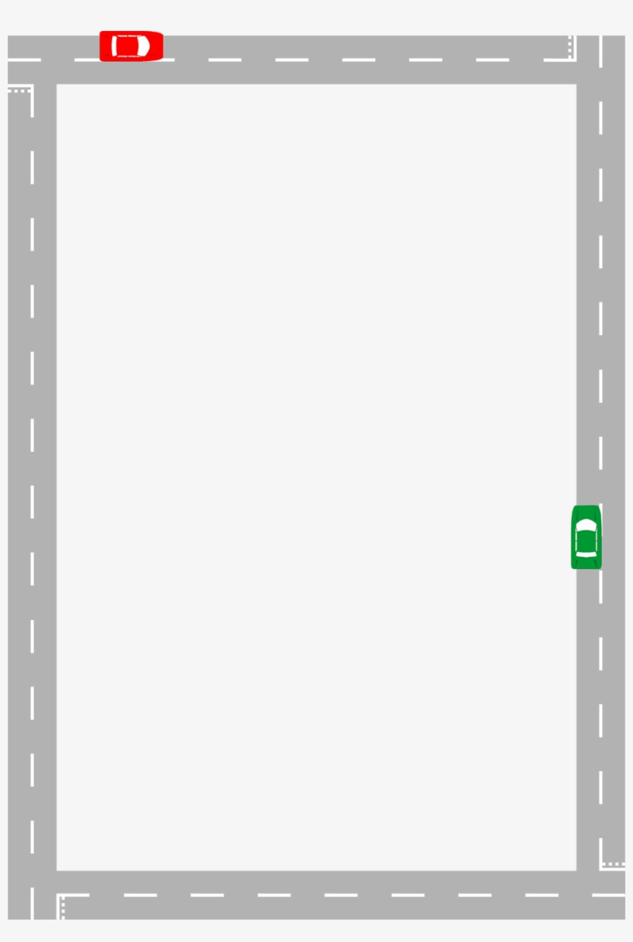

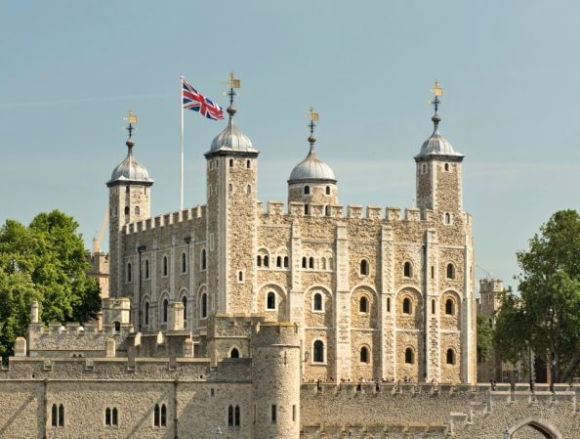
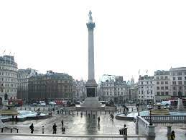
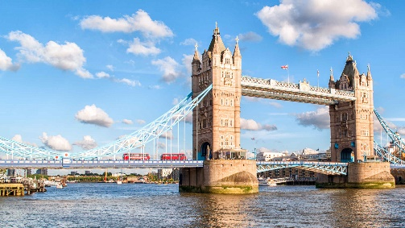
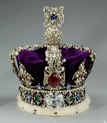
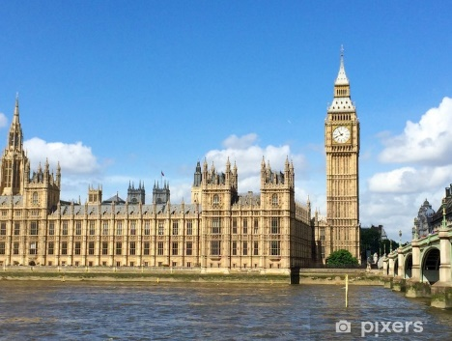
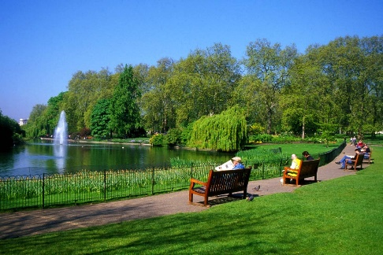
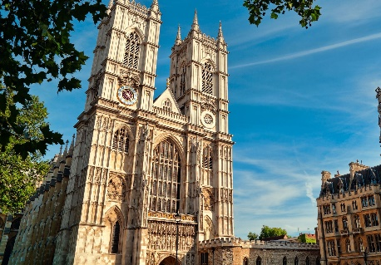
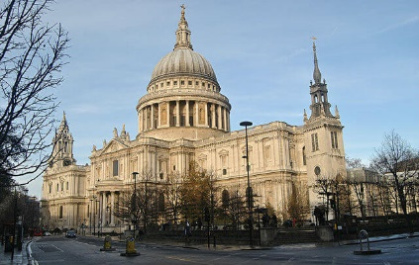
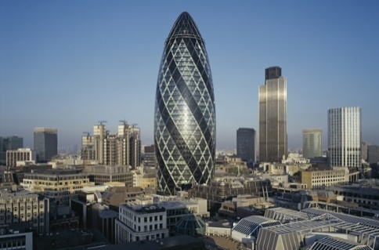
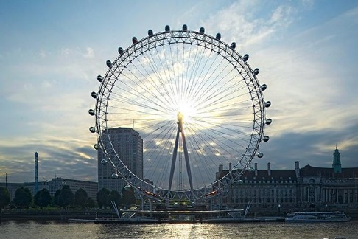
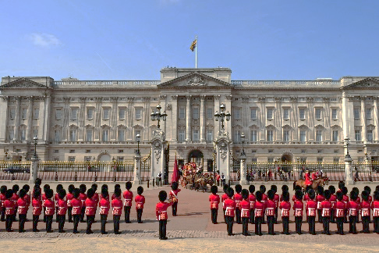
It includes the House of Lords and the House and the House of Commons. They debate and vote on new laws.
The clock tower is very famous!
It is a very famous symbol of London. It crosses the Thames.
It is a very animated place in London. Take a photo of Nelson’s column! He defeated Napoleon at the Battle of Trafalgar (1805)
To mark the Millenium, an enormous wheel (135m high) was built. For a magical view over London, buy a ticket!
The Tower of London
It is a very important place for Anglican people. You can recognize its beautiful dome.
The Gherkin
Hyde Park
Buckingham Palace
Westminster Abbey

