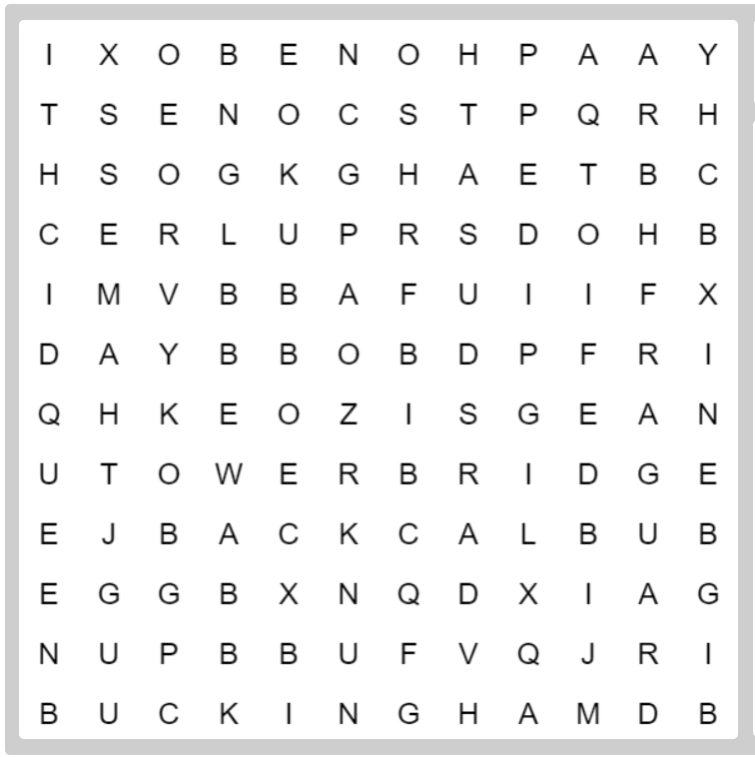
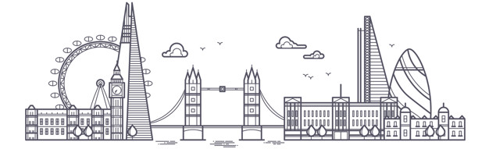
London
BLACK CAB THAMES BUCKINGHAM
PHONE BOX TEA TOWER BRIDGE
SCONES GUARD BOBBY
CHIPS BIG BEN QUEEN FISH

London
BLACKCAB THAMES BUCKINGHAM
PHONE BOX TEA TOWER BRIDGE
SCONES GUARD BOBBY
CHIPS BIG BEN QUEEN FISH

London
BLACK CAB THAMES BUCKINGHAM
PHONE BOX TEA TOWER BRIDGE
SCONES GUARD BOBBY
CHIPS BIG BEN QUEEN FISH

