Directions
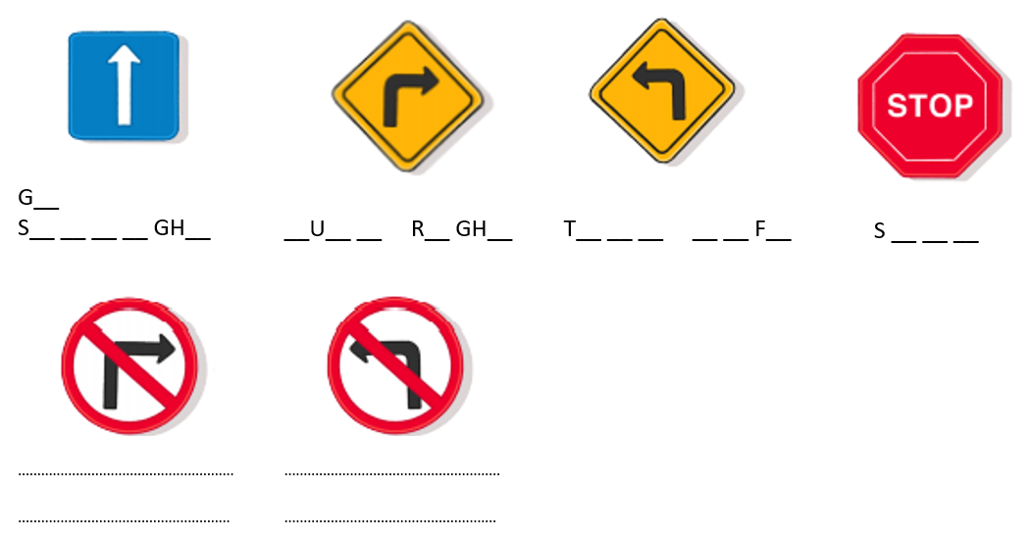

- Listen and complete the instructions.

__O
A__ __ R __ __ S

Directions
- Listen and complete the instructions.

__O
A__ __ R __ __ S

