

A road trip to the US

PLANNING MY TRIP


What DO YOU NEED before leaving?


- I need _ _ _ _ _ _ _ _ _ _ .
- In the US we need _ _ _ _ _ _ _ _ _ .
1$ = 0.83€
- How much are…
100$ = _ _ _ _ 2000$ = _ _ _ _
1500$ = _ _ _ _ 10000$= _ _ _ _
- Prepare your budget here:
In your opinion, how much do you need to go to the US?
Transport | Accommodation | Food | Activities | Gifts
I need _ _ _ _ _ _ _ _ _ _ _ to have a nice trip!



- I need _ _ _ _ _ _ _ _ _ with _ _ _ _ _ _ _.
I
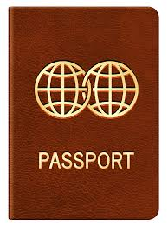


- I need official documents.
- I need _ _ _ _ _ _ _ _ _ _ _ _ _
- I _ _ _ _ _ _ _ _ _ _ _ _ _ _
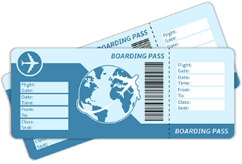
- I _ _ _ _ _ _ _ _ _ _ _ _ _ _

