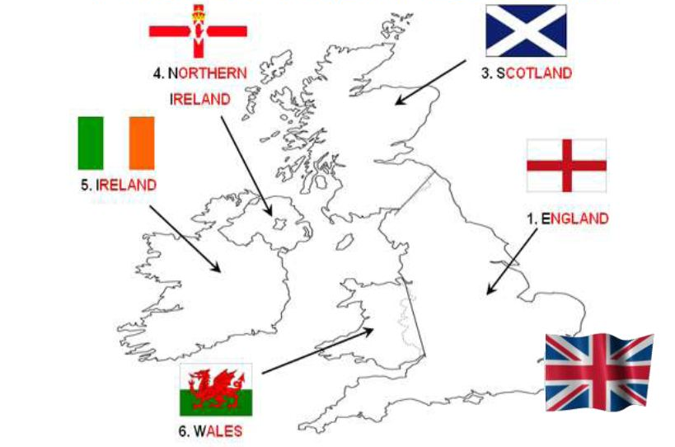
Cardiff
The leek and the daffodil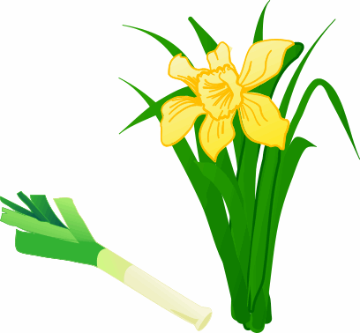
London
the rose

The thistle

Edinburgh
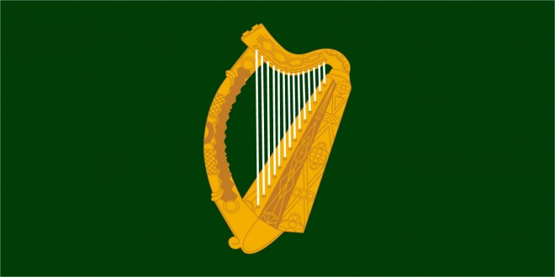the harp

Dublin
Belfast

The shamrock

……………………………………………………….…….………………………………..…………………..…………………………………………………….
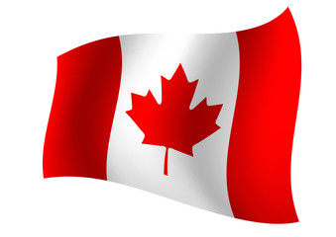CANADA
…………

My name is __________________________________
I live in _________________________________
I am ___________ (my birthday is on _______________________)
I study _______________________ at Risle Seine

SOUTH AFRICA …………
INDIA
…………
AUSTRALIA  NEW ZEALAND ………… ………… …………

………… ………… …………
…………

The United States of America
JAMAICA



