Why science writing prompts?
The prompts help students to concentrate on a concept, brainstorm individually or in a group and focus their effort/writing. Through the writing prompts students improve their writing skills, review concepts, allow teachers to assess learning, enhance creativity and help students in integrating science to other subjects.

Standards
SPS7. Students will determine relationships among force, mass, and motion.
a. Apply Newton’s three laws to everyday situations by explaining the following:
- Inertia
- Relationship between force, mass and acceleration
- Equal and opposite forces
S8P5: Students will recognize characteristics of gravity, electricity, and magnetism as major kinds of forces acting in nature.
a. Recognize that every object exerts gravitational force on every other object and that the force exerted depends on how much mass the objects have and how far apart they are.
S8P3. Students will investigate relationship between force, mass, and the motion of objects.
- Determine the relationship between velocity and acceleration.
- Demonstrate the effect of balanced and unbalanced forces on an object in terms of gravity, inertia, and friction.

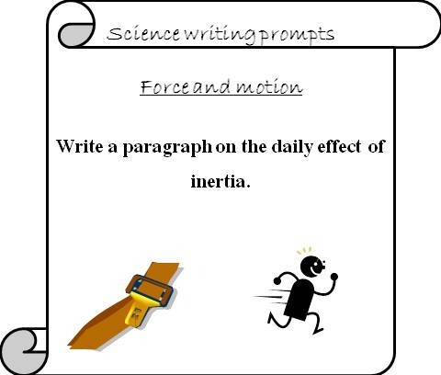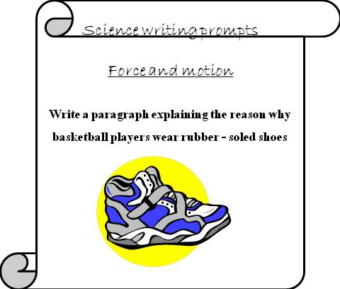
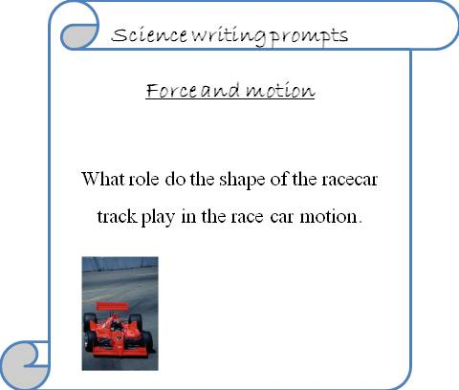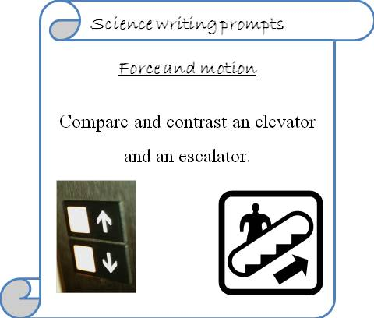
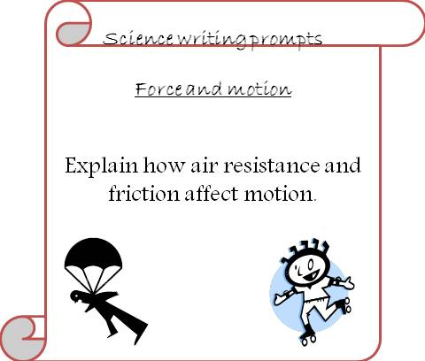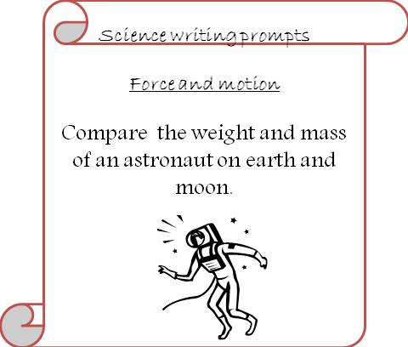

****Cut the prompts and allow students to write on the back.

Copyright
TIDEs
www.tidesinc.org
© 2013 TIDEs

All rights reserved. No part of this publication may be reproduced or transmitted in any form or by any means, electronic or mechanical, including photocopy, or any information storage and retrieval system, without permission from the publisher.
This resource was created by TIDEs © 2013. It may be printed and photocopied by the original purchaser for single classroom and personal use only. It may not be put on the internet, sold, or distributed in any form. If you would like to share this resource with your colleagues, please refer them to http://www.teacherspayteachers.com/Store/Tides to purchase a single copy, or you may purchase multiple licenses at a discount.
For more resources visit
http://www.teacherspayteachers.com/Store/Tides


