START | I have 4 sides the same length and 4 right angles
Square | I have 4 sides and 4 right angles, two sets of sides are the same length
Rectangle | I have one side
Circle | I have 3 sides
Triangle | I have 4 sides the same length and no right angles
Rhombus | I have 4 sides, no right angles and 2 sets of sides the same length
Parallelogram | I have 2 sides, one curved and one straight
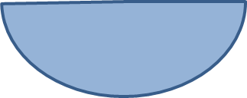  Semi-circle | I have five sides
Pentagon | I have 10 sides
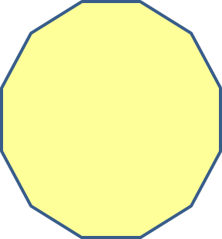  Decagon | I have 12 sides
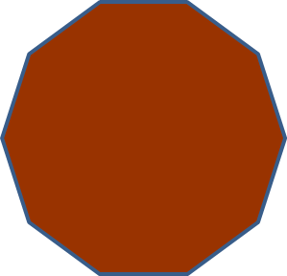  Dodecagon | I have 8 sides
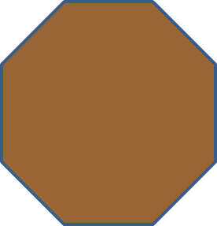  Octagon | I have 7 sides
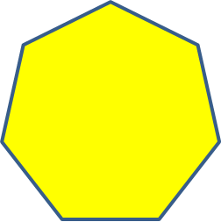  Heptagon | I have 6 sides
Hexagon | FINISH

