Audio Tour- USA
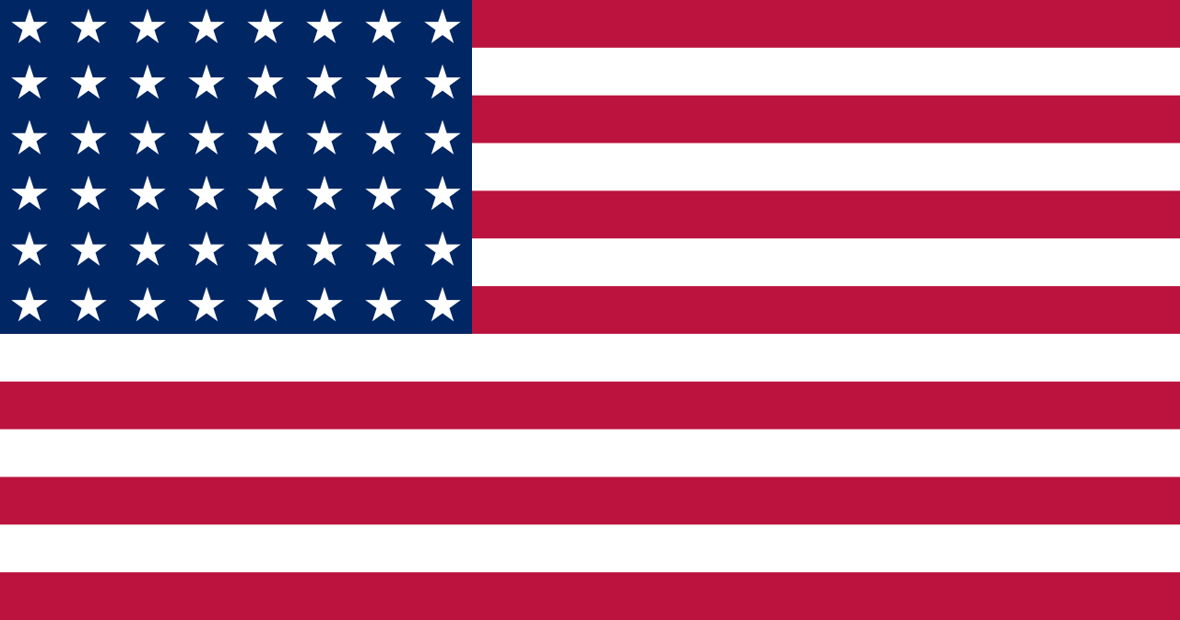

The _______ of the USA is ________ __________ and _________ ( colours).
It has 50 __________ and 13 ____________.
The 50 stars represent the 50 ______________.
The 13 stripes stand for the 13 ______________ that signed the ____________________ of ___________________ on July 4th, 1776.
The USA is a big country. It is _________ times bigger than France! There are a lot of large cities.
1. ______________’s nickname is “the Big Apple”. It is the most populated city in the USA. There are 8 million inhabitants.
2. _____________is famous for a building called the Space Needle. 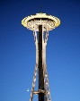 It is in the _______________________ of the USA ( location).
Cette photo par Auteur inconnu est soumis à la licence CC BY-NC

3.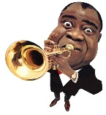 ___________________________ is famous because it is the birthplace of jazz.
4. Chicago is a very big city. It is the start of _________________________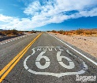.

5. ______________ is on the west coast. It is famous for the ______________ ________ _____________. 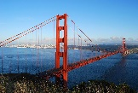
6. The president of the USA lives and works in the __________ ___________ 
in the capital of the USA: ________________________
7. ______________ is famous for its universities. It is in the ____________ of the USA. (location)
8.  ______________________ is a very large city . It is the capital of ____________.

