FIGHT FOR YOUR RIGHTS !

Racial tensions in the USA

1-Janelle Monae's protest song : « Hell you talmbout »-2015
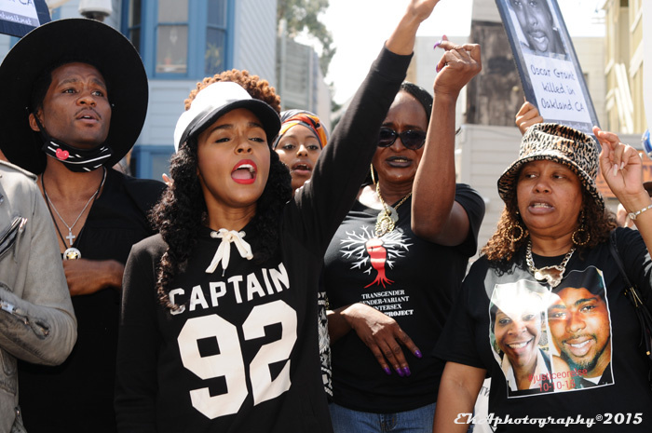
Watch the video : what is it about ?does it show ? What does it say ?

It is about police brutality and systemic racism in the USA. It shows victims of police brutality.The singers ask us to say their names , for them not to be forgotten, and for people to be aware of how numerous the victims are.

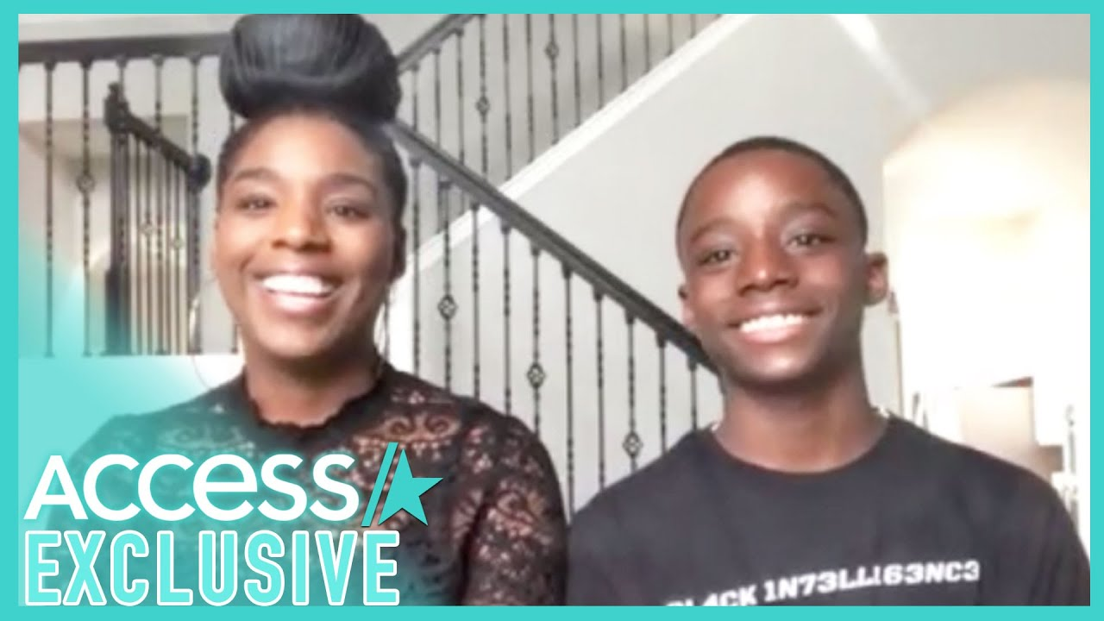
2-Interview of Keedron Bryant-2020

Listen to the interview , complete the script and answer the questions

1-What kind of document is it ? (music video,radio/tv program,reality tv show...)

It’s a tv interview.

2-What is it about ?

About a 14 year-old boy who posted a video of him singing a song he had created as a reaction to George Floyd

3-Quote three adjectives the journalist uses to describe Keedron's performance :

powerful-beautifu -heartbreaking

4-What is the song about ? it’s about Black Americans’ struggle and fear in a country where racism is still very much alive and where police brutality still kills black people.

5-What is « we've had enough struggle (épreuves/luttes) » referring to ?

The struggles they have waged since they arrived in America to achive equality : slavery , lynchings, segregation, police brutality

6-How many views did the song get ? 3 million

7-Who reposted it ? Barack Obama , Lebron James

8-Listen and complete the script :

Journalist : (..) But first miss Johnetta , you wrote this song, it came from deep in your soul, what made you put these words on paper ?

Johnetta : In light of everything that is going on especially our recent situation, when I heard Mr Floyd call out for his mum, as a black mother that really hit me in a deep way.
and I began to pray and so I said « god this world needs help like never before ».

So I went into meditation because I needed to understand ,
strength, because I also knew that I need to be able to give my son some wisdom that's gonna help him to be able to live and to be confident in this world.(...)

Journalist : When you sing this song , I'm wondering what are you feeling... you feel these words, this isn't about singing a song , what are you feeling when you're singing those words?

Keedron : I felt sad that I had to sing that because it's unfair that we can’t go out and like the song says live. I just wanna live, we can't go out and enjoy life and not be afraid or fear that something's gonna happen to us.
So it is really sad to have that feeling.

9- What do these two documents tell us about the situation concerning African-Americans in the USA nowadays ?

That racism and discrimination are still alive and black people are still afraid they might become a victim of it one day .

10- What is Keedron sad about ? Explain

He’s sad that because of it , young African Americans can’t really enjoy life like they’re supposed to , without fear.

11- Find the words for :

ces : these confiant : confident

se passer ( 2 ) : go on se demander :wonder
happen

en tant que : as ressentir:feel

frapper : hit être obligé de:have to

en profondeur : deep injuste : unfair

plus que jamais : like never before apprécier/profiter : enjoy

compréhension : understanding avoir peur : be afraid

être capable de be able to peur : fear

sagesse : wisdom nous arriver : happen to us

12- Find the irregular past for these words then write their meaning in French:

write : wrote _____________________________
make made_____________________________
put : put______________________________
hear : heard_______________________________
hit :hit _______________________________
begin :began_____________________________
say :said_______________________________
go : went ________________________________
know :knew_____________________________
feel :felt_______________________________

