AN INTRODCTION TO « STRANGE FRUIT »
I-Read and write what you understand in French(the main ideas in each paragraph)

The poem
It was named the song of the century by Time magazine in 1999.It is originally a poem written by the Jewish school teacher Abel Meeropol in response to lynching in US southern states.He wrote Strange Fruit after seeing Lawrence Beitler’s distressing photograph of the 1930 lynching of Thomas Shipp and Abram Smith in Indiana.The poem became a song sang by Billie Holliday in 1939 It was named the song of the century by Time magazine in 1999 It has been covered (reprise) by many artists and still is ! ( Rhapsody 2019).
Lynching
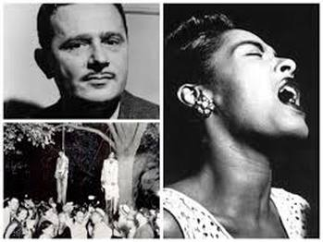

Lynchings were a method of social and racial control meant to terrorize black Americans into submission. They became widely practiced in the US south from roughly 1877 through 1950.
A typical lynching would involve ( comprenait) criminal accusations, often dubious ( douteuses), against a black American, an arrest, and a “lynch mob”( une foule de « lyncheurs ») instead of ( au lieu de) the normal judicial process ( processus judiciaire).
Victims would be seized ( étaient saisies) and subjected to every imaginable physical torture, with the torture usually ending with being hung( pendu) from a tree and set on fire. The victims would often be dismembered ( démembrées) and mob members would take pieces of their flesh (chair) and bone ( os ) as souvenirs.

Very often, the mobs were aided by the police. Officers would leave a black prisoner’s prison cell unguarded to allow for a mob to kill them before any trial (procès).
There were at least 4,743 victims of lynchings between 1881 and 1968 but the true number of lynchings is dramatically underreported.
For those (ces) white Americans, lynching was a way of maintaining order,a warning to not challenge the white supremacy but it was also a joyous moment of celebration : “Whole families came together, bringing even their youngest children. It was the show of the countryside ” read a 1930 article. “Men joked at the sight ( à la vue de) of the bleeding body … girls giggled ( pouffaient de rire) as the flies (mouches) fed on the blood that dripped from the Negro’s nose.”
The vast majority of lynching participants were never punished, both because of the tacit approval of the police, and because dozens if not hundreds often had a hand in the killing.
Lynchings slowed around 1950 with the coming of the civil rights movement. the terror switched modes by “the development of other extra-legal means of control, such as bombings, incendiarism, threats and intimidation”.
Extracts from an article : https://www.theguardian.com/us-news/2018/apr/26/lynchings-memorial-us-south-montgomery-alabama
II - Listen to these covers and samples of « Strange Fruit » over the years and say

1- why the song has been named « the song of the century »
2-What does it show when Jade Novah , one of these artists said about her cover ? :

"How can you be an artist, and not reflect the times?" Nina Simone asked this very question decades ago, and how unfortunate is it that her song, "Strange Fruit," is STILL a reflection of our current time? As an artist, I wanted to share my rendition of this haunting song, to not only pay homage to the legendary Billie Holiday & Nina Simone, but as a tribute to black lives...we matter. »

3-Look at the dates of the covers , knowing that the Black Lives Matter movement started in 2013 , what do you notice ?

4-Which one is your favourite song from the list below ? why ?

Billie Holiday’s song ( 1939)
https://www.youtube.com/results?search_query=strange+fruit+billie+holiday
Nina Simone’s cover ( 1965)
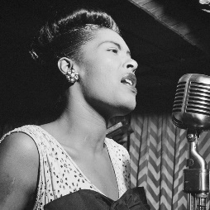
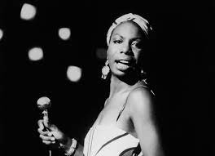
https://www.youtube.com/watch?v=BnuEMdUUrZQ
India Arie’s cover(2004)
https://www.youtube.com/watch?v=SP74hBZlUuc
Common feat. John Legend ( sample)- 2011
https://www.youtube.com/watch?v=0L3B0-ajza8
Kanye West « Blood on the leaves » ( sample)-2013
https://www.youtube.com/results?search_query=strange+fruit+kanye+west
Jill Scott’s cover ( 2015)
https://www.youtube.com/watch?v=A0TcI5ib35M
Jade Novah’s cover ( 2017)
https://www.youtube.com/watch?v=n-zfirLtNQA
Rhapsody-Nina ( sample) – 2019
https://www.youtube.com/watch?v=1oY1jQTvcQE

