LESSON 1
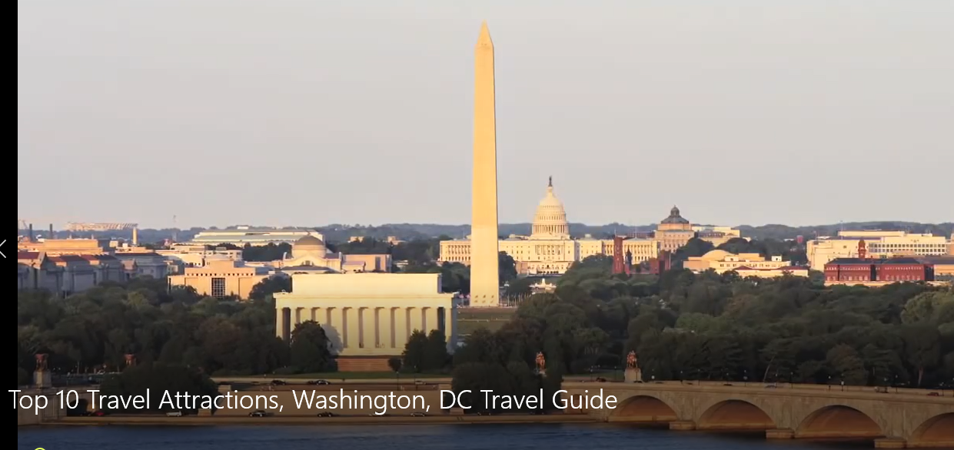
Washington DC top attractions
 | NAME | DESCRIPTION
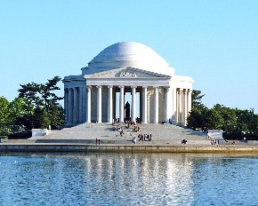 | Jefferson Memorial | It was ____________ to Thomas __________ , the __________ US president.
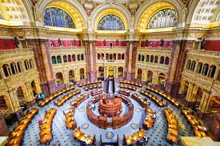 | Library of congress | It is__________________ library in the world !
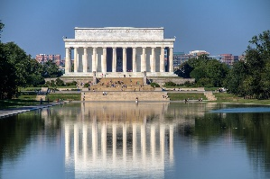 | Lincoln memorial | It was dedicated to______________________, the________US president ( who______________ slavery).
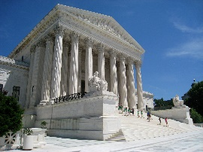 | Supreme court | Among the country’s ________ important _________________.
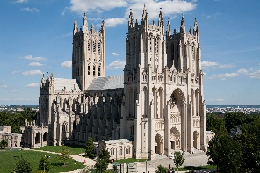 | National cathedral | It is the most________ known US ____________________.
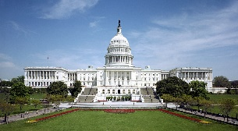 | The Capitol | It is where the US ____________ and the__________ of representatives meet.
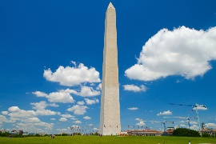 | Washington monument | It is dedicated to___________  ____________________ the _________ president of the United States.
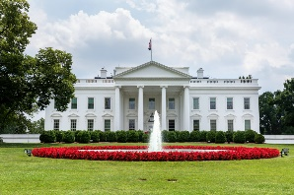 | The White House | Symbolically the most important______________ in the country.The US president _______ and________ there.
The video presents the most interesting places to visit in the city.

