
The Civil War

Part 1 – What led to the Civil War? Complete the tables.
a, How it started:
When? | In 1860 and 1861
How many states seceded? | 11 Southern states seceded.
What does “secede(d)” mean? | They left the United States to make their own country.

b, The two enemies:
Name | Union | Confederacy
President | Abraham Lincoln (USA) | Jefferson Davis

Part 2 – The reasons. Finish the sentence. Answer the question.
a, The secession was like “the trigger” for the Civil War, the real reason was the disagreement over slavery.
b, A trigger is a cause to start a war. Translate trigger in French. déclencheur
Part 3 – The beginning of the war. Complete the table.
When? | In April 1861
What? | Confederate soldiers fired on Fort Sumter.
Where? | Fort Sumter, South Carolina
Why? | Confederate soldiers wanted Fort Sumter for their own military use.
The consequences: | President Lincoln declared the South in rebellion. The Civil War began.

Part 4 – The Civil War’s beginnings. Label the pictures.
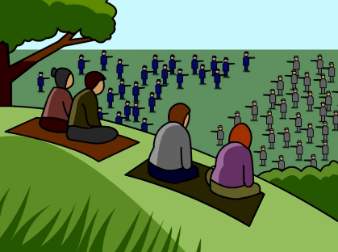
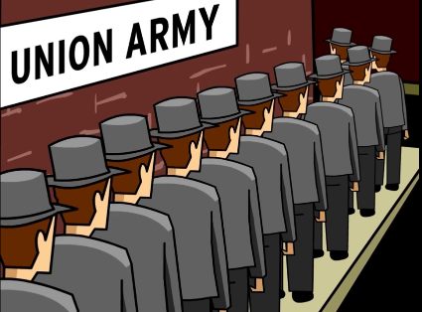

What was his title?

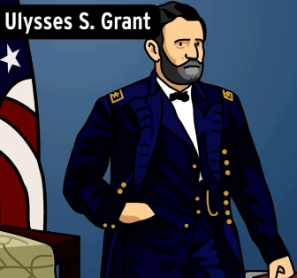
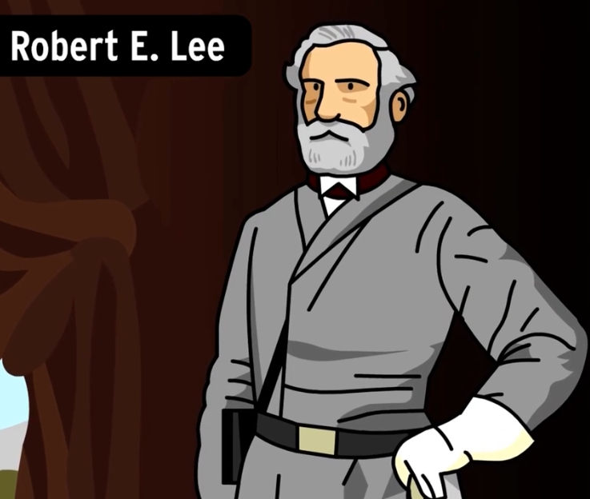
Whose part was he on? (Confederate/ Union)
Whose part was he on? (Confederate/ Union)
What was his title?

Which opponent won the First Battle of Bull Run? __________________________________________________

Part 5 – The Emancipation Proclamation

Who? | Lincoln
When? | In 1863.
Why? | To free all slaves in the Confederate states.

True or false?
a, The Northern States still held slaves. T F
Correction: ______________________________________________________________________________________
b, The border states (like Maryland) still held slaves. T F
Correction: ______________________________________________________________________________________
c, The Confederacy formed units of the African American soldiers. T F
Correction: ______________________________________________________________________________________
d, Slavery was abolished in 1865. T F
Correction: ______________________________________________________________________________________
e, The Battle of the First Battle of Bull Run was a turning point. T F
Correction: ______________________________________________________________________________________

Part 6 The end of the Civil War. Write the keywords next to the picture.

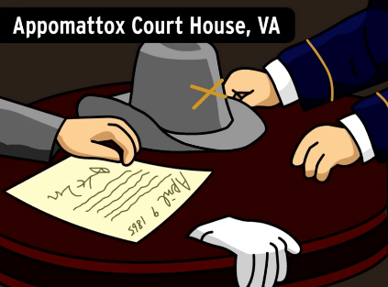
In April 9th 1865 Commander Lee surrendered to General Grant.

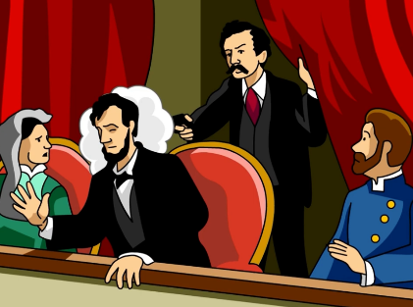
Abraham Lincoln was assassinated in Washington DC in a theater.

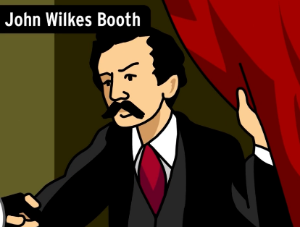

John Wilkes Booth was an actor from Maryland who was angry at Lincoln for abolishing slavery.

