LAST NAME, first name: Class:

Black History month – évaluation des connaissances /20 points

ALWAYS write full sentences!

1. Triangular Trade

a. Why was it worth for the Europeans to do these trips? (to worth = valoir le coup)
0 0.5 1 / 1p

b. What is the name of the route between West-Africa and the Americas? 0 0.5 1 / 1p

c. How were the captives treated on the ships? Write 2 sentences, use the passive voice!
0 0.5 1 1.5 2 / 2p

2. The life on the plantations

a. What is this? When was it used? 0 0.5 1 1.5 2 / 2p

b. Write about the working conditions of field slaves!
(2 pieces of information, use the expressions of prohibition and obligation) 0 0.5 1 1.5 2 / 2p

3. The Civil War

What was the real reason for starting the Civil War? 0 0.5 1 / 1p

What happened to the slaves as a result? 0 0.5 1 / 1p

4. Segregation

a. What was “segregation” in the USA? Tell with your own words. 0 0.5 1 / 1p

b. Write 2 Jim Crow laws using your own words. (use the expressions for prohibition and obligation)
0 0.5 1 1.5 2 / 2p

c. Who contributed to the abolition of segregation ? How ? (min. two people) 0 0.5 1 1.5 2 / 2p

5. African American people in the USA nowadays

What events and movement does this picture evoke? Write about them.
0 0.5 1 1.5 2 / 2p

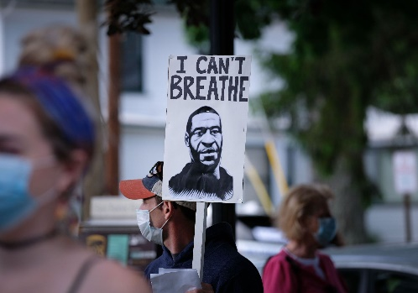

Grammar: 0 0.5 1 1.5 2 2.5 3 / 3p

