Watch the extract from the film Ali. answer the questions (a, b, c) or complete the sentences (d, e, f)
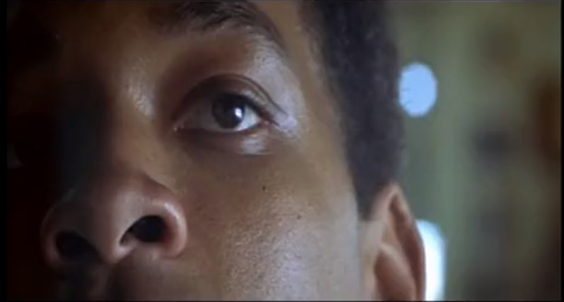
a. What is Ali doing during the whole extract?
…………………………………………………………………

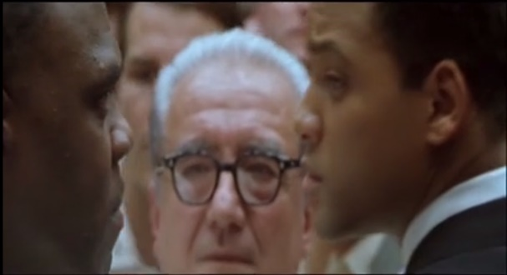
b. The other boxer says:
“I’m going to beat you, like I was your daddy.”
Why would he say that?
………………………………………………………………………

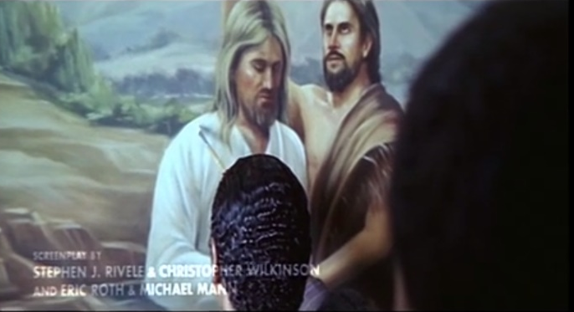
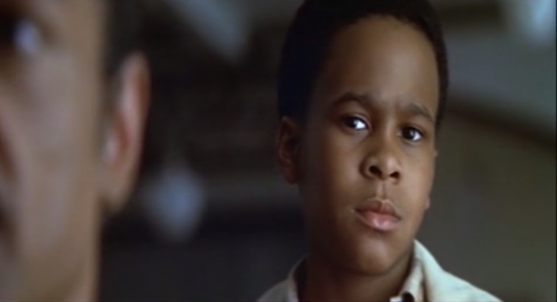
c. Who is on the painting?
…………………………………………………………
How does Ali feel?
…………………………………………………………
Why?
…………………………………………………………
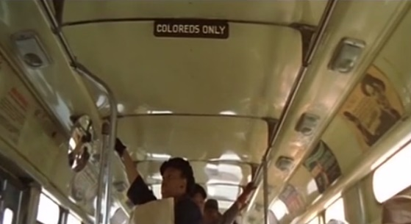
…………………………………………………………
d. When Ali was a child, black people had to sit at the ____________ of the bus, while white people sat at the front. We call this period in the USA ______________________.

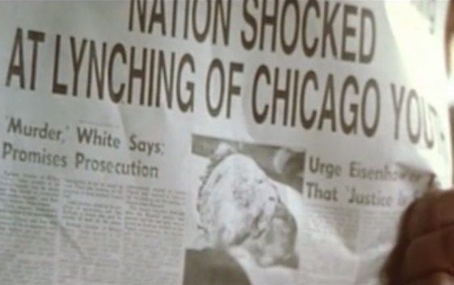
e. This newspaper covers the tragic death of 14-year-old Emmett Till, an A___________- A____________________ boy from ____________________. He was brutally ____________________ by white men, supposedly for flirting with a white woman. The crime was rightly recognised as a ______________________ by many Americans.
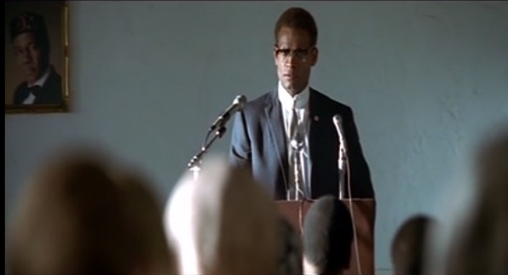
f. Who is he? Underline the right answer.
Martin Luther King Malcolm X
Complete his quote: “Your times will not get better, unless you _______________ them _______________.”
and
“We don’t teach you to ______________ the other ___________”
Watch the extract from the film Ali. answer the questions (a, b, c) or complete the sentences (d, e, f)
a. What is Ali doing during the whole extract?
…………………………………………………………………

b. The other boxer says:
“I’m going to beat you, like I was your daddy.”
Why would he say that?
………………………………………………………………………

c. Who is on the painting?
…………………………………………………………
How does Ali feel?
…………………………………………………………
Why?
…………………………………………………………
…………………………………………………………
d. When Ali was a child, black people had to sit at the ____________ of the bus, while white people sat at the front. We call this period in the USA ______________________.

e. This newspaper covers the tragic death of 14-year-old Emmett Till, an A___________- A____________________ boy from ____________________. He was brutally ____________________ by white men, supposedly for flirting with a white woman. The crime was rightly recognised as a ______________________ by many Americans.
f. Who is he? Underline the right answer.
Martin Luther King Malcolm X
Complete his quote: “Your times will not get better, unless you _______________ them _______________.”
and
“We don’t teach you to ______________ the other ___________”

